## Overview

In this activity, you will practice rotating and scaling prebuilt elements on your page.

These effects will lead you to build engaging interfaces, especially in combination with upcoming activities.

## Instructions

**Rotate:**

1. Open index.html located in Activities / 01_transforms and index.css located in Activities / 01_transforms / css.
2. Inside index.css, find the selector that targets images nested in an element with the rotate class.
3. Add transform: rotate(180deg); to this selector. What will it do to the image of the dog?

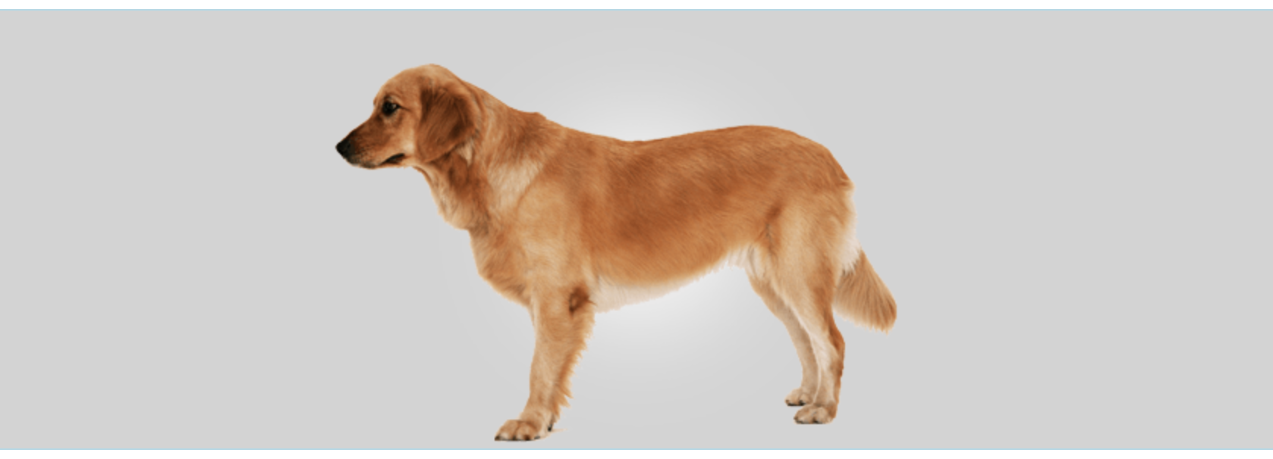

1. Try other values (even negative numbers) for rotate and see what happens.

**Scale:**

1. Find the .scaleMe selector and give this a property of transform: scale(2);.
   * What do you think this will do to the size of the red square?
2. Try out scaling along the x-axis and y-axis using scaleX() and scaleY() or the shorthand of scale(x,y).

**Translate:**

1. Find the .moveMe selector and give this a property of transform: translate(80%, 40%);.
   * What do you think this will do to the blue square?
   * The blue square will be moved from the left by the first value and the top by the second value.
   * How would you move something from the right and bottom?
2. Try out translate along the x-axis and y-axis using translateX() and translateY() or the shorthand of scale(x,y).

**Bonus:**

1. Try out other 2D and 3D transformations. Read more [here](https://developer.mozilla.org/en-US/docs/Web/CSS/transform).